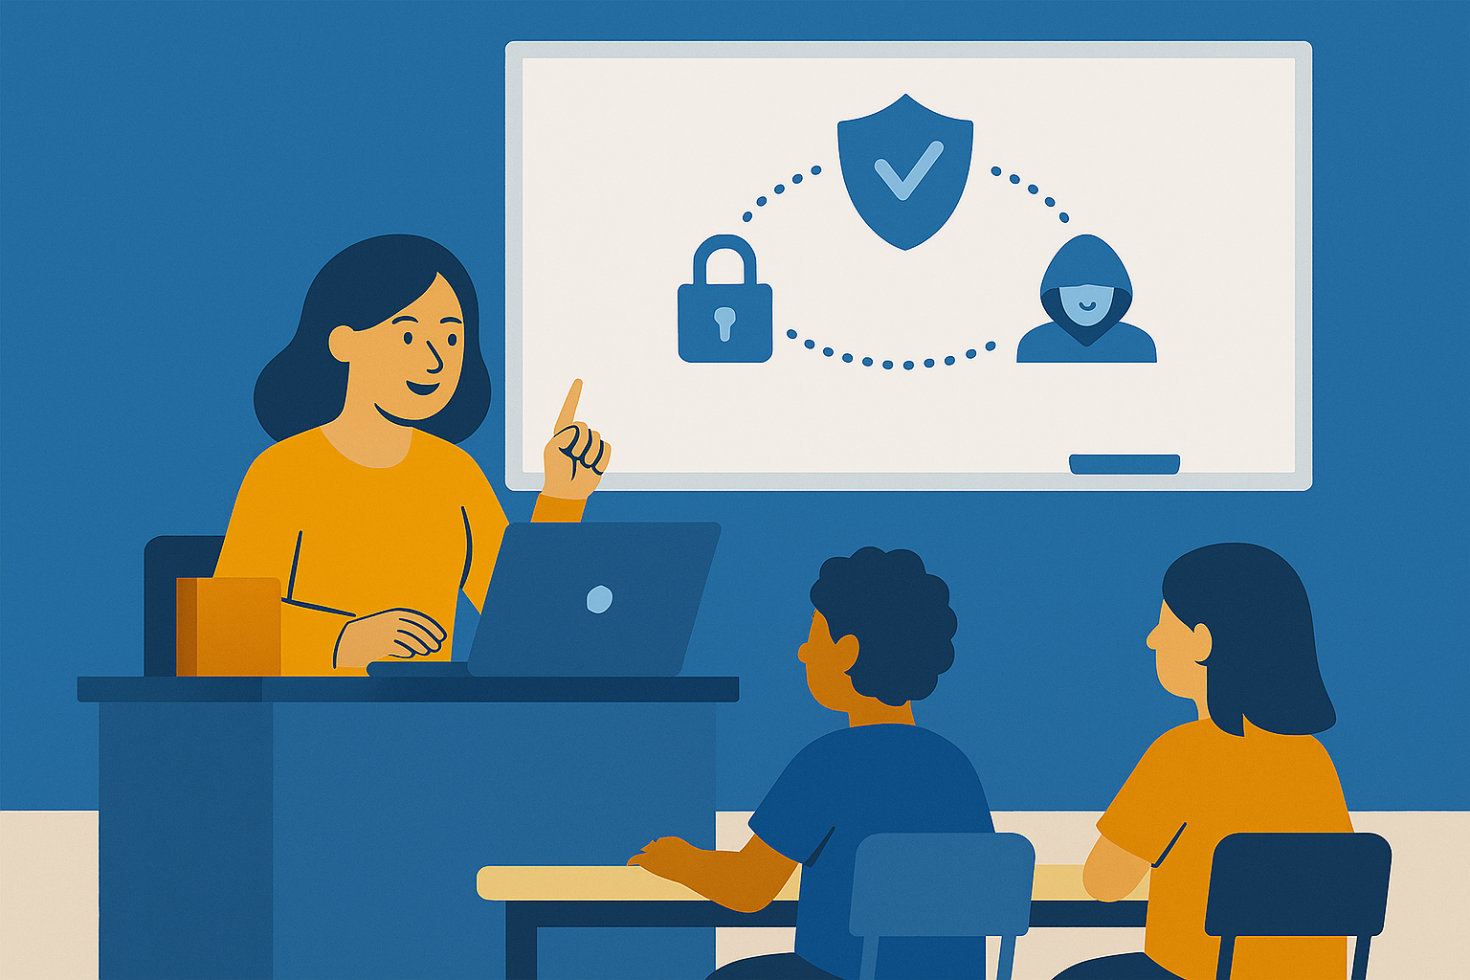

Cyber Hygiene in Schools:

A Practical Guide to Online Safety

• Anila Kola – teacher – profile: English Language  
• Arlinda Nikolli – teacher – profile: History-Geography  
• Jonida Prenga – teacher – profile: Information Technology and Communication

 In collaboration with Kevin Locaj – Master in Cyber Crime and Terrorism

**Contents**

**Introduction………………………………………………………………………………………………..4**

1. **Understanding Cyber Hygiene in the Educational Context……………………………………………………………………………….………..…...5**
2. **The Landscape of Cyber Threats: A Risk Analysis for Schools……………………………………………………………………………………………..7**
3. **Key Components of Effective Cyber Hygiene…………………………………………………………………………………………….8**
4. **Integrating Cyber Hygiene into School Policies and Culture……………………………………………………………………………….…………….10**
5. **Curriculum-Based Cybersecurity Education…………………………………..…………………………………………………….11**
6. **Family and Community Engagement in Cyber Hygiene……………………………………………………….……………………………………..12**
7. **Legal and Ethical Aspects in the Protection of Student Data……………………………………………………………………..…………………………….14**
8. **Incident Response Planning and Risk Mitigation……………………………………………………………………………………….....15**
9. **International Case Studies on Cybersecurity in Schools……………………………………………………………………………………………….16**
10. **Psychosocial Impact of Cyber Threats on Students……………………………………………………….……………………………………..18**

**Conclusion………………………………………………………………………………………………….…20  
Bibliography….…………………………………………………………………………………………..….21**

**Abstract**

In the digital era, where technology has become an inseparable part of our daily lives, security in the virtual environment is just as important as in the physical one. Schools, as fundamental educational institutions, play a key role in shaping safe habits and behaviors among students in the online world. It is precisely from this awareness that the initiative to create the e-book *“Cyber Hygiene in Schools”* was born, as a product of a project with the same title, within the framework of professional practice as a director candidate, in the CSL School Leadership Program.

This guide was prepared by Anila Kola, Arlinda Nikolli, and Jonida Prenga, in collaboration with Kevin Locaj, an expert in Cyber Crime and Terrorism, with the aim of serving as a practical tool for teachers, students, and school leaders to raise awareness and strengthen the skills necessary to navigate safely in the digital space. The objective is to support schools in building a healthy digital culture—where privacy is respected, technology is used responsibly, and ethical behavior online is promoted.

This e-book represents a modest but meaningful contribution to the field of cybersecurity education and comes as a response to the growing need for proper guidance in facing the challenges that internet use poses in school environments. We hope this material will serve as a starting point for broader education and action policies aimed at a safer, more inclusive, and contemporary educational system.

**Introduction**

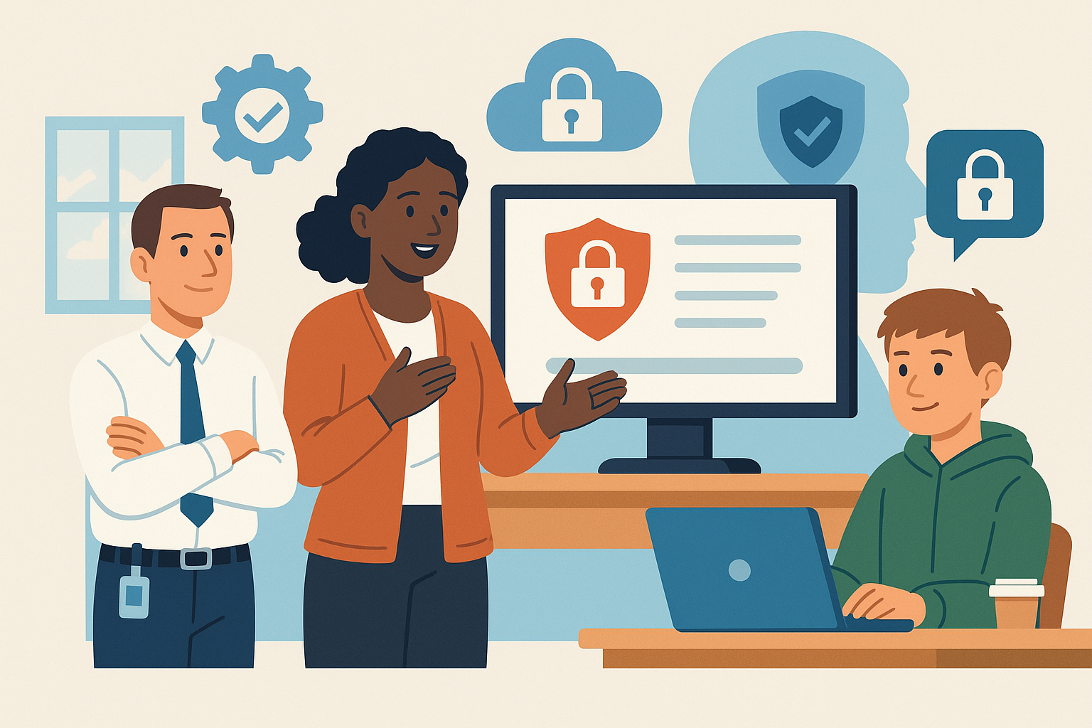

The integration of digital technologies in education has transformed the way students learn, teachers teach, and schools operate. With the rise of one-to-one device programs, learning management systems, and cloud-based educational platforms, digital literacy has become a cornerstone of 21st-century education. However, this shift has also significantly increased the exposure of students and schools to cyber threats. From phishing schemes targeting school administrators to the rise of ransomware attacks on educational institutions, the need for robust cybersecurity practices in schools has never been more urgent (CISA, 2022).

Cyber hygiene refers to the routine and proactive measures that individuals and institutions take to maintain system integrity and protect data from unauthorized access or compromise. In the context of K–12 and secondary education, cyber hygiene is not only a technical necessity but also a fundamental component of student safety and digital citizenship. According to a 2021 report by the Consortium for School Networking (CoSN), over 90% of school districts reported cybersecurity as a top priority, yet fewer than 30% had dedicated cybersecurity personnel.

Students are uniquely vulnerable in the digital environment due to their developmental stage, lack of experience, and widespread use of social media and collaborative online tools. Cyberbullying, identity theft, exposure to inappropriate content, and data tracking are just a few of the risks they may encounter. Furthermore, the digital divide exacerbates these vulnerabilities, as students with limited access to devices and digital literacy support may not receive the same level of protection or education about safe online practices (Livingstone & Byrne, 2018).

This paper aims to provide a comprehensive framework for implementing cyber hygiene in schools, addressing not only the technical aspects but also the pedagogical, social, and legal dimensions. It draws on best practices from national and international education and cybersecurity organizations, as well as academic research and case studies. The goal is to equip educators, administrators, students, and families with the knowledge and tools necessary to create a secure and responsible digital learning environment.

Key questions guiding this inquiry include: What are the most common cyber threats faced by schools today? How can educators and school leaders develop and enforce effective cybersecurity policies? What role should students and families play in maintaining cyber hygiene? And how can schools integrate cybersecurity education across disciplines and grade levels?

Ultimately, fostering a culture of cyber hygiene in schools is a shared responsibility that involves every member of the educational ecosystem. With thoughtful planning, inclusive policies, and ongoing professional development, schools can not only mitigate cyber risks but also empower students to become resilient, ethical, and digitally literate citizens.

1. **Understanding Cyber Hygiene in Educational Contexts**



Cyber hygiene, much like physical hygiene, is an ongoing process that involves conscious, habitual actions aimed at safeguarding one's digital presence and technology use. In the context of education, it encompasses a broad range of practices that ensure students, teachers, and administrators engage with digital tools in a secure and responsible manner. The rise of digital classrooms, online assessments, and cloud-based school management systems has made the implementation of effective cyber hygiene not just advisable but essential (ENISA, 2021).

The core of cyber hygiene in schools begins with understanding what needs protection: devices, personal data, student records, communication platforms, and network infrastructure. Schools are custodians of a vast amount of sensitive data, from personally identifiable information (PII) of students and staff to confidential administrative documents. This data, if not adequately protected, becomes a prime target for cybercriminals who exploit security loopholes through malware, ransomware, or phishing tactics (CISA, 2022).

Fundamental components of cyber hygiene include device security (such as antivirus software and firewalls), regular software updates and patch management, proper password management (including two-factor authentication), and secure cloud storage practices. However, technical measures alone are not sufficient. Just as important are behavioral norms and education. Teachers and students must be trained to recognize suspicious emails, use secure networks, and handle data ethically and responsibly (Cyber.org, 2023).

Establishing a culture of cyber hygiene requires an environment where digital safety is a shared responsibility. Administrators must lead by example, ensuring that security protocols are in place and regularly updated. Teachers should embed digital citizenship lessons into everyday classroom interactions, promoting healthy screen habits, privacy awareness, and empathy online. Students, as digital natives, must be empowered with the knowledge and skills to navigate online spaces critically and safely (Livingstone & Byrne, 2018).

This integration of technical tools with educational initiatives forms the basis for a robust cyber hygiene ecosystem. Moreover, school policies and community practices should reinforce this foundation. Schools that actively collaborate with parents and guardians on digital safety matters are more likely to succeed in building a consistent message around responsible technology use (Common Sense Media, 2022).

Cyber hygiene in education must also address equity. Not all students have the same access to safe, secure technology or adult support. Cyber hygiene initiatives should be inclusive, ensuring that underserved and vulnerable student populations receive the tools and training necessary to protect themselves online. Whether through in-school instruction, take-home guides, or multilingual resources, equitable access to cybersecurity education is a fundamental right in today’s learning landscape.

The cultivation of cyber hygiene is therefore more than a matter of IT—it is a whole-school approach that includes policy, pedagogy, infrastructure, and community. When integrated thoughtfully, these components create a digitally safe and empowered school culture that prepares students not only to avoid threats, but to become responsible participants in the digital world.

1. **Cyber Threat Landscape: A Risk Analysis for Schools**

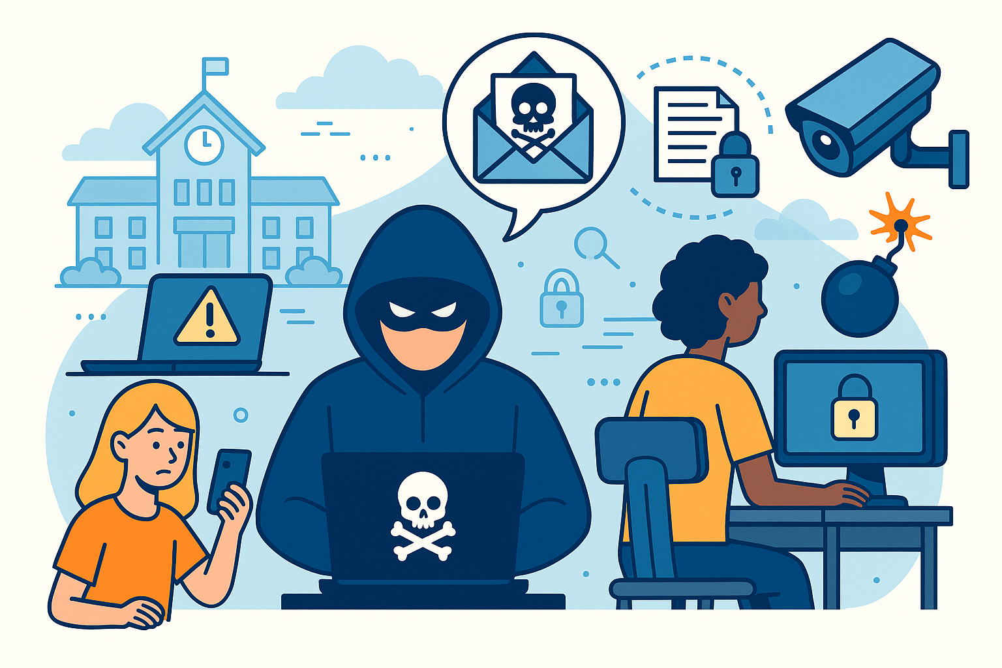

The cyber threat landscape confronting educational institutions has expanded dramatically in both complexity and scale. As schools adopt more connected technologies and remote learning infrastructures, they inadvertently widen the attack surface for malicious actors. The COVID-19 pandemic significantly accelerated this digital shift, leaving many school systems unprepared for the security implications (CISA, 2022). Consequently, schools have become lucrative targets for cybercriminals, not only because of the sensitive data they store but also due to the relative lack of dedicated cybersecurity personnel and funding in the education sector (K12 SIX, 2021).

One of the most pervasive threats in educational environments is phishing. These attacks typically involve deceptive emails designed to trick recipients into revealing login credentials or downloading malware. Phishing has evolved in sophistication, with attackers often impersonating trusted figures such as school principals, IT support, or popular online services used by students. Once credentials are compromised, attackers can access grading systems, email servers, and cloud drives, potentially disrupting educational operations and compromising personal information.

Ransomware is another major concern. These attacks encrypt school data and demand payment for its release. The financial and operational impact can be devastating. In 2020, the Baltimore County Public Schools were forced to cancel classes for several days due to a ransomware attack, while the costs of recovery and lost instructional time mounted into the millions (K12 SIX, 2021). Schools with limited backup systems or without disaster recovery plans are especially vulnerable to such scenarios.

Beyond these high-profile threats, educational institutions face constant risks from data leaks, insider threats, and software vulnerabilities. Many school systems use a patchwork of third-party applications, some of which lack proper security vetting or fail to adhere to privacy regulations. Even benign negligence, such as students or teachers using outdated passwords or connecting to unsecured public Wi-Fi, can open the door to cyberattacks.

Social engineering attacks also deserve special attention. These involve manipulating individuals into divulging confidential information or performing insecure actions. Students are particularly susceptible, given their developmental stage and frequent social media use (Livingstone & Byrne, 2018). Attackers might pose as classmates or influencers, using psychological manipulation to gain access to private data or spread harmful content.

A growing concern is the use of surveillance technology in schools, such as facial recognition or keystroke monitoring software. While intended for safety or academic integrity, these tools can introduce new vectors for abuse and data exploitation if not properly secured. They also raise ethical questions about student privacy and consent, especially when minors are involved (Cowan et al., 2021).

To address this broad threat landscape, schools must adopt a multilayered cybersecurity strategy. This includes investing in secure infrastructure, adopting rigorous digital policies, and most critically, educating all users—staff and students alike—on safe digital behavior. Continuous risk assessment and collaboration with national cybersecurity agencies can further strengthen schools' resilience against evolving threats (NCSC, 2022).

Understanding the diverse nature of cyber threats is essential for prioritizing defenses, allocating resources effectively, and fostering a proactive, rather than reactive, security posture in educational settings.

1. **Key Components of Effective Cyber Hygiene**

Effective cyber hygiene in educational environments is multifaceted, encompassing both technical defenses and human-centered practices. Schools must adopt an integrated approach that equips users with the tools, knowledge, and behaviors necessary to minimize cybersecurity risks while fostering a proactive security mindset across all stakeholders (ENISA, 2021).

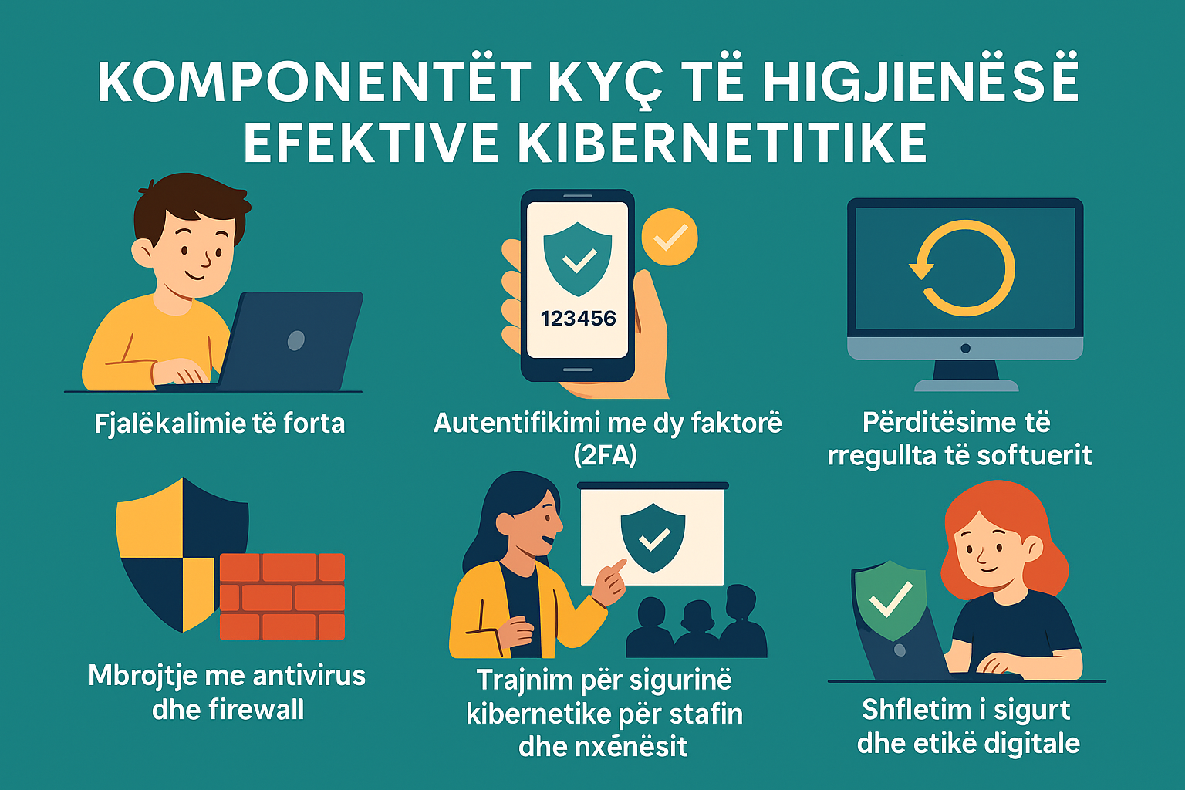

A cornerstone of cyber hygiene is secure password management. Students, educators, and administrators should be trained to create complex, unique passwords using combinations of upper- and lowercase letters, numbers, and symbols. Password reuse across platforms must be discouraged, as it allows attackers who compromise one account to potentially access others. Institutions should implement password rotation policies and encourage the use of password managers approved by IT departments to reduce the burden of memorization and improve overall security (NIST, 2020).

Two-factor or multi-factor authentication (MFA) adds another critical layer of protection. MFA requires users to verify their identity through a second method, such as a temporary code sent to a mobile device or biometric identification. According to Microsoft, MFA can prevent over 99% of account compromise attacks when properly implemented (Microsoft, 2021). Schools should prioritize MFA for access to sensitive systems, including student records, email platforms, and cloud-based services.

Timely software updates and patch management are also essential. Unpatched software represents one of the most exploited vulnerabilities in educational systems. School IT departments must implement centralized patching protocols and ensure all devices, including those used remotely by students, receive regular security updates. Automatic update configurations and secure boot settings further reduce the risk of exploitation (CISA, 2022).

Device-level protections such as antivirus software, firewalls, and endpoint detection systems form the backbone of digital defense. These tools can detect and neutralize threats before they escalate, particularly when configured to provide real-time monitoring. Schools should use enterprise-grade cybersecurity solutions that support cloud management and reporting features, allowing administrators to track incidents and maintain compliance across a network of distributed devices (CoSN, 2021).

However, cybersecurity is not purely technical. Behavioral awareness is equally crucial. Staff and students should receive routine training on recognizing phishing emails, identifying suspicious links, and responding to data breaches or device compromises. These programs should include interactive simulations and role-playing scenarios that enhance learning retention and preparedness (Cyber.org, 2023).

Additionally, schools should promote safe browsing habits and the responsible use of social media. Students need to understand the implications of oversharing personal information and how digital actions can have long-term reputational and security consequences. Lessons in digital citizenship and ethics must be embedded into curricula across age groups and disciplines (Common Sense Media, 2022).

Cyber hygiene also requires consistent and transparent communication. IT departments must maintain open channels to report security incidents, suspected phishing attempts, or technical anomalies. The establishment of clear reporting procedures empowers users to act swiftly when encountering cyber threats (NCSC, 2022).

Finally, regular cybersecurity audits and vulnerability assessments should be conducted by external partners or in-house professionals. These evaluations help identify weaknesses, ensure policy enforcement, and inform the continual improvement of cyber hygiene strategies (EDUCAUSE, 2021).

By combining technical safeguards, educational programming, and a culture of vigilance, schools can create a resilient cyber environment where students and staff are both protected and empowered.

1. **Integrating Cyber Hygiene into School Policies and Culture**

For cyber hygiene practices to be sustainable and effective, they must be codified into institutional policy and embedded into the cultural fabric of the school environment. A policy-driven approach ensures consistency in expectations and provides the foundation for accountability, enforcement, and evaluation. However, policies alone are insufficient without school-wide participation and cultural reinforcement.

The first step is to establish comprehensive Acceptable Use Policies (AUPs) that outline clear guidelines for digital conduct by students, teachers, and staff. These policies should define permissible uses of school-provided technology, restrictions on device sharing, and behaviors related to email, file downloads, social media access, and data protection. Importantly, AUPs should be written in accessible language and tailored to different age groups to ensure comprehension and compliance (Common Sense Media, 2022).

Involving students in the creation of a “Cyber Hygiene Charter” can be an effective strategy for fostering engagement and ownership. By collaborating with school administrators and IT staff, students can help co-author a set of values and behaviors that promote responsible technology use. This participatory approach not only encourages adherence but also reinforces peer accountability and cultivates leadership.



Professional development for teachers is a critical component of cyber hygiene integration. Educators must be equipped with the knowledge to model secure practices, guide students in ethical digital behavior, and recognize early signs of cyber threats or misuse. Ongoing training should address emerging trends, such as social engineering tactics or mobile device vulnerabilities, and be reinforced with practical classroom resources (Cybersecurity and Infrastructure Security Agency [CISA], 2022).

School leaders must also designate roles and responsibilities for cybersecurity oversight. This might include appointing a digital safety coordinator or forming a cybersecurity committee comprising IT personnel, educators, parents, and even students. This group should meet regularly to review incidents, evaluate current policies, and implement improvements. Regularly updated incident response plans should also be distributed across departments, ensuring that all stakeholders know how to respond to cyber incidents.

Creating a culture of trust is equally important. Students must feel safe reporting cybersecurity issues without fear of punishment or ridicule. Anonymized reporting tools, classroom discussions on online dilemmas, and schoolwide events like Digital Safety Week can help normalize conversations about cybersecurity.

Integration must also extend beyond the classroom. Family engagement is vital. Schools should offer workshops and materials for parents, educating them on the tools their children use and how they can support cyber hygiene at home. Multilingual resources and community partnerships can further extend the reach of these initiatives, particularly in diverse school districts.

When cyber hygiene becomes a shared value—supported by thoughtful policies, inclusive practices, and a culture of awareness—schools are better positioned to defend against threats and support students in becoming conscientious digital citizens. Policy integration is not a one-time task but an evolving process that requires adaptability, collaboration, and commitment across all levels of the educational community.

1. **Curriculum-Based Cybersecurity Education**

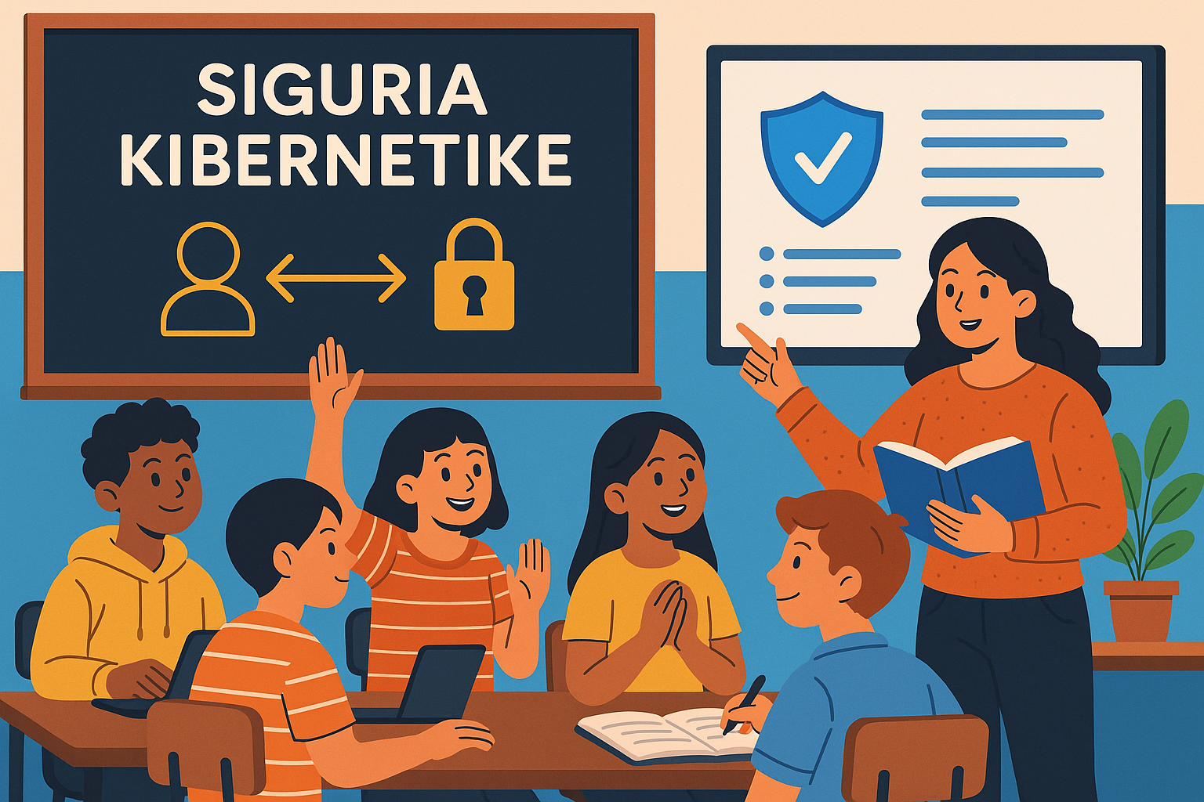

Integrating cybersecurity education into school curricula is one of the most powerful ways to promote long-term cyber hygiene. Rather than treating digital safety as a separate or optional subject, effective schools embed cybersecurity themes across disciplines and grade levels, ensuring that all students gain the skills necessary to navigate a complex digital world.

At the foundational level, students should begin learning about safe online behaviors from as early as primary school. Age-appropriate instruction can include lessons on how to protect personal information, identify safe websites, and understand the basics of respectful online communication. Interactive games and storytelling are highly effective at this stage, allowing younger students to learn digital safety concepts through play and relatable scenarios (Be Internet Awesome, 2023).

As students progress to middle and secondary levels, the curriculum can expand to include topics such as cyberbullying prevention, phishing awareness, password management, social engineering, and an introduction to coding and ethical hacking principles. These lessons not only improve individual cyber hygiene but also build critical thinking and digital literacy. Cross-curricular integration is key; for example, discussions of misinformation and privacy can be incorporated into language arts and social studies, while mathematics and computing classes can explore data encryption and cryptographic algorithms (K-12 Cybersecurity Learning Standards, 2022).

Educator preparedness is central to successful implementation. Teachers require professional development that provides them with accurate, up-to-date knowledge and engaging teaching strategies. Unfortunately, many educators lack formal training in cybersecurity and feel ill-equipped to address the topic in class. National initiatives such as Cyber.org, the U.S. Department of Education’s CTE cybersecurity pathways, and the EU’s Digital Education Action Plan provide free resources and lesson plans that can support teacher confidence and capacity (Cybersecurity & Infrastructure Security Agency, 2022).

Project-based learning is a particularly effective method for reinforcing cybersecurity skills. Students can be tasked with designing schoolwide awareness campaigns, developing secure mobile apps, or participating in cybersecurity competitions like CyberPatriot or the European Cybersecurity Challenge. These activities foster collaboration, leadership, and a practical understanding of cybersecurity principles (Cecchinato et al., 2021).

Inclusion and equity must be prioritized throughout curriculum development. Underrepresented groups, particularly girls, low-income students, and minority populations, are often excluded from STEM and cybersecurity programs due to systemic barriers or lack of targeted outreach. Initiatives such as Girls Who Code and Code.org’s equity framework offer strategies to close participation gaps and ensure that cybersecurity education is accessible and empowering for all learners.

In summary, cybersecurity education should not be reactive but anticipatory, equipping students with both the technical know-how and ethical awareness to operate safely and confidently in digital environments. A curriculum that is interdisciplinary, inclusive, and experientially rich will prepare young people to be not just cyber-aware, but cyber-resilient.

1. **Family and Community Engagement in Cyber Hygiene**

Cyber hygiene is most effective when it extends beyond the school setting and into the home and broader community. Schools that engage families and community partners in cybersecurity efforts create more comprehensive and sustainable models of digital safety. Given that students spend significant time online outside the classroom—often with less supervision—families must be equipped to reinforce the principles of safe digital behavior.

A first step is providing parents and caregivers with accessible, culturally relevant resources that explain key cybersecurity concepts and offer practical strategies. Materials should cover topics such as how to manage home Wi-Fi networks, monitor children’s screen time, use parental controls, and identify signs of online exploitation or cyberbullying. Organizations like Internet Matters and ConnectSafely have developed toolkits specifically designed for parents to foster safer technology use at home (Internet Matters, 2023).

Workshops and webinars hosted by schools or local nonprofits can provide interactive forums for family engagement. These sessions might address emerging threats such as sextortion, gaming scams, or social media misinformation. Schools can also partner with public libraries, community centers, or faith-based organizations to expand outreach and accessibility. Multilingual materials and interpreters should be made available to ensure inclusion in linguistically diverse communities.

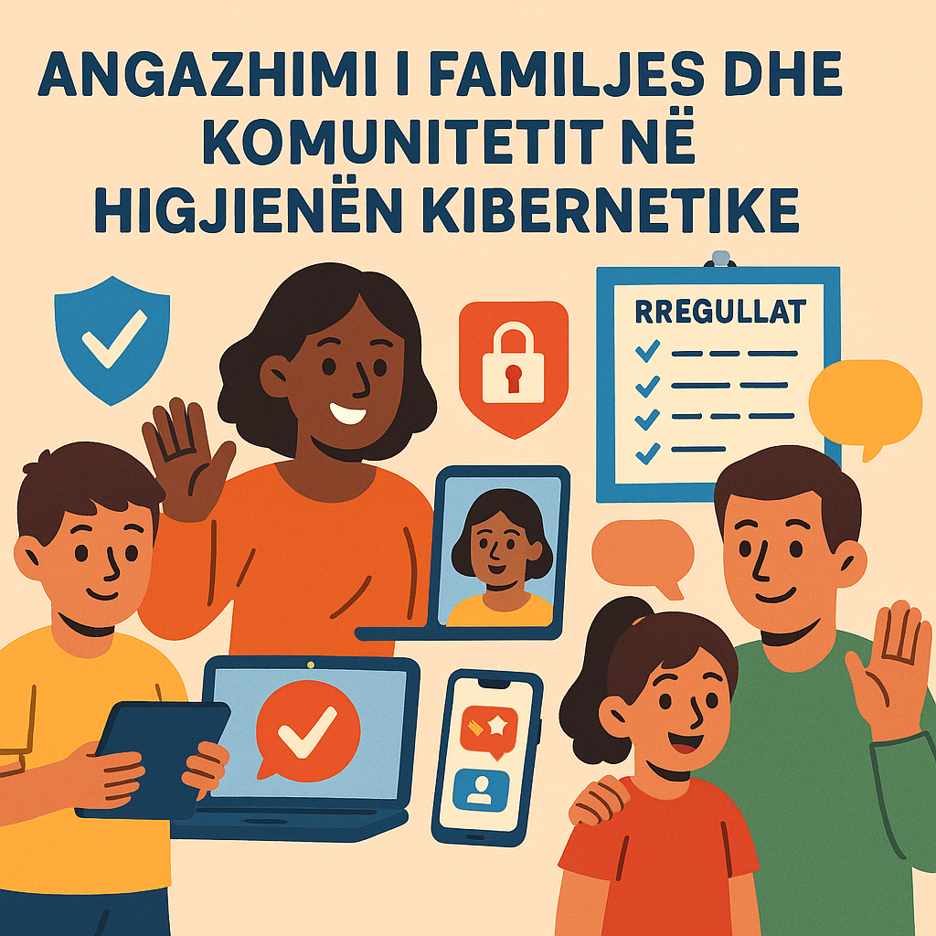

Effective engagement also involves empowering families to collaborate in developing schoolwide cyber hygiene strategies. Parents can serve on digital safety committees, contribute to reviewing Acceptable Use Policies (AUPs), or help facilitate student-led cybersecurity events. Including family voices in planning and decision-making builds trust and strengthens the community’s role in protecting students online (Family Online Safety Institute, 2022).

Technology companies and civic organizations can also be valuable allies. Public-private partnerships may provide schools with training resources, devices, or funding for cybersecurity initiatives. Programs like Google's Family Link, Mozilla’s Internet Health Report, or the National PTA’s Smart Talk guide offer structured guidance for joint digital decision-making between parents and children.

Importantly, digital safety messaging must align across all environments where children interact. For example, consistency between school policies, home practices, and public campaigns reduces confusion and reinforces behavioral norms. Schools should encourage regular conversations between students and families about online risks and responses, ideally using school-provided prompts or conversation guides.

By building strong, informed partnerships with families and community organizations, schools extend the reach and impact of their cyber hygiene efforts. A united front ensures that students are supported in developing secure, respectful, and responsible online behaviors—wherever they may log in from.

1. **Legal and Ethical Considerations in Student Data Protection**

The collection, storage, and use of student data raise significant legal and ethical concerns that schools must address proactively. With educational institutions increasingly relying on digital platforms to manage academic records, learning analytics, and communication tools, the potential for misuse or mishandling of personal information grows. A well-rounded cyber hygiene framework must therefore account for both compliance with regulatory standards and the promotion of ethical data stewardship.

Legally, schools in many countries are subject to strict data protection laws. In the European Union, the General Data Protection Regulation (GDPR) requires schools to secure parental consent for processing children’s data, conduct Data Protection Impact Assessments (DPIAs) when implementing new technologies, and ensure transparency in data collection practices. Noncompliance can result in significant fines and reputational damage. Meanwhile, in the United States, the Family Educational Rights and Privacy Act (FERPA) and the Children’s Online Privacy Protection Act (COPPA) govern the use of student data, emphasizing the rights of parents to access and control educational records and limiting the collection of information from children under 13 (U.S. Department of Education, 2021).

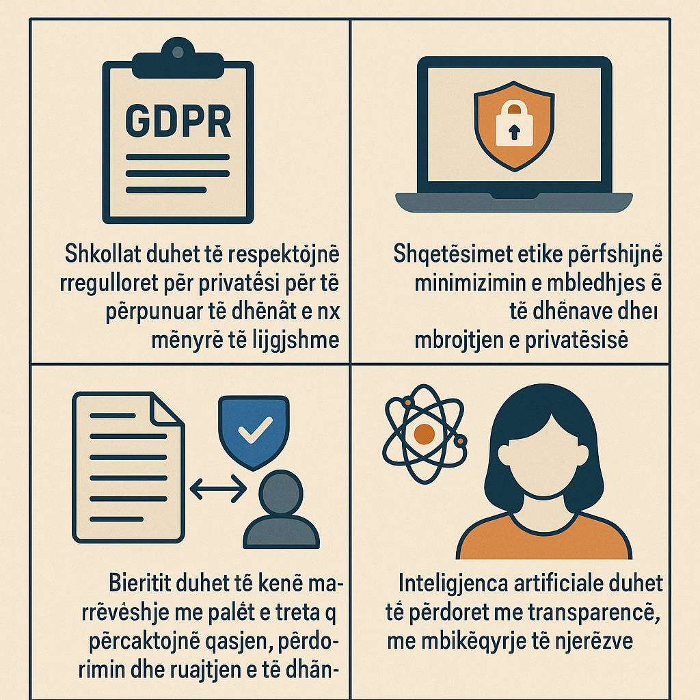

Despite these regulations, gaps in enforcement and interpretation persist. Many third-party educational technology providers operate in legal gray areas, offering tools that collect large volumes of behavioral and biometric data without clear user understanding. Schools must rigorously vet digital vendors and establish formal agreements that define data access rights, retention periods, and breach response protocols (Privacy International, 2020).

Beyond legal obligations, ethical considerations are central to creating a responsible digital learning environment. Schools must recognize the asymmetry of power between institutions and students—particularly minors—when it comes to data. Ethical stewardship demands that schools limit data collection to what is strictly necessary, avoid invasive surveillance technologies, and educate students about their digital rights and responsibilities (OECD, 2022).

A growing concern is the use of artificial intelligence and algorithmic decision-making in educational settings. Predictive analytics tools may help identify students at risk of failure or dropout, but they also risk reinforcing biases or infringing on privacy. Transparency in how these systems operate, as well as opportunities for human oversight and appeal, are essential ethical safeguards (European Commission, 2021).

Moreover, digital citizenship education should include discussions on data privacy, informed consent, and the societal implications of surveillance capitalism. Encouraging students to critically examine how their information is collected and used—both within and beyond school systems—fosters a generation of more empowered and ethical technology users.

In short, legal compliance is the floor, not the ceiling, of responsible student data protection. Schools must combine rigorous adherence to regulations with a principled commitment to ethical practice, ensuring that technology serves the educational mission without compromising the dignity or autonomy of learners.

1. **Incident Response Planning and Risk Mitigation**

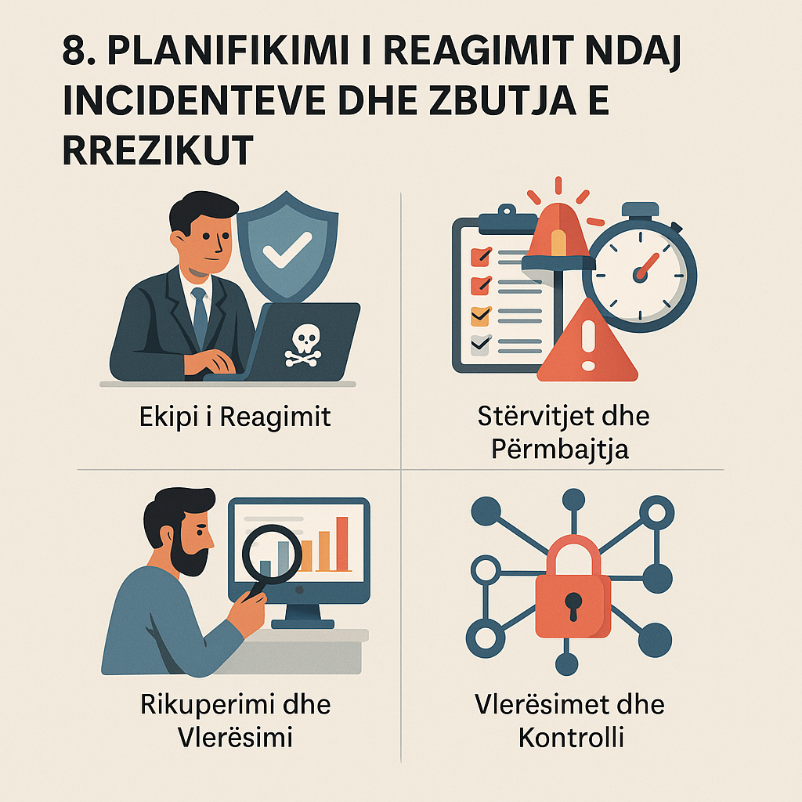

Despite best efforts to prevent cyber threats, no system is completely immune. Therefore, schools must develop and regularly update comprehensive incident response plans (IRPs) to guide actions when cybersecurity breaches occur. An IRP outlines the procedures and responsibilities required to detect, contain, respond to, and recover from cyber incidents such as ransomware attacks, data breaches, and denial-of-service (DoS) events.

A robust IRP typically includes the formation of a multidisciplinary response team composed of IT staff, school administrators, legal advisors, communications personnel, and—in some cases—local law enforcement or cybersecurity consultants. Each team member should have clearly defined roles and access to emergency contact information and secure communication channels. These teams are responsible for coordinating a timely response that prioritizes both system restoration and transparency with affected stakeholders (Ponemon Institute, 2020).

Preparation is key. Schools should conduct regular tabletop exercises and simulations to test their response capabilities under realistic conditions. These drills should assess the effectiveness of escalation protocols, decision-making processes, and communication strategies. Outcomes should inform continuous improvements to the response plan and training content.

During an actual incident, early detection and containment are essential. Monitoring systems should be capable of identifying anomalies, unauthorized access attempts, and malware activity. Once an issue is confirmed, the response team must act swiftly to isolate affected systems and prevent further spread. Simultaneously, internal and external communications must be initiated, ensuring that staff, students, families, and partners are informed without causing panic or disclosing sensitive information (National Institute of Standards and Technology [NIST], 2021).

Post-incident recovery efforts include restoring data from backups, conducting forensic analysis to determine the root cause, and documenting the entire event for legal and auditing purposes. Schools must also assess the breach’s impact on learning continuity, public trust, and institutional reputation. Transparent reporting to regulators and, when appropriate, the public is critical for maintaining accountability and improving sector-wide resilience (Data Quality Campaign, 2022).

Risk mitigation complements incident response by reducing the likelihood of attacks and minimizing their potential impact. This involves conducting regular risk assessments, segmenting networks to restrict intruder movement, implementing least privilege access controls, and maintaining up-to-date inventories of all hardware and software. Schools should also establish clear bring-your-own-device (BYOD) policies and prohibit the use of unsupported or unauthorized applications (Center for Internet Security, 2022).

Ultimately, incident response and risk mitigation must be integrated into school operations, not treated as isolated IT responsibilities. By fostering a culture of preparedness and continuous improvement, schools can build resilience against evolving threats and maintain the trust of their communities.

1. **International Case Studies in School Cybersecurity**

Examining how different countries and educational systems address cybersecurity offers valuable insights for improving school cyber hygiene practices globally. While contexts vary widely, successful initiatives often share common elements: strong policy frameworks, centralized support, community engagement, and investment in capacity building.

In the United Kingdom, the National Cyber Security Centre (NCSC) has played a pivotal role in guiding cybersecurity practices across educational institutions. Their “Cyber Security for Schools” toolkit provides resources such as policy templates, audit checklists, and staff training modules. Additionally, UK schools benefit from partnerships with law enforcement and national CERT teams to manage cyber incidents and report emerging threats. Schools are encouraged to undergo cybersecurity self-assessments and share anonymized data to inform national policy development (NCSC, 2022).

In Finland, cybersecurity is embedded directly into the national core curriculum from an early age. Students are introduced to digital safety concepts in primary education, with lessons extending into ethical technology use, data protection, and media literacy. The Finnish model emphasizes equity, ensuring that all students—regardless of socio-economic background—have access to high-quality digital education and support. This systemic integration has been praised for promoting not only competence but also civic responsibility in digital environments (European Schoolnet, 2021).

Australia has adopted a federated yet cohesive approach through its eSafety Commissioner, which provides guidance to both public and private schools. The platform offers resources tailored for students, parents, and educators, addressing cyberbullying, image-based abuse, and digital wellbeing. It also maintains reporting tools for online harms, enabling swift institutional responses to incidents. Schools are encouraged to build cyber safety into their wellbeing policies and foster cross-sectoral collaboration (eSafety Commissioner, 2022).

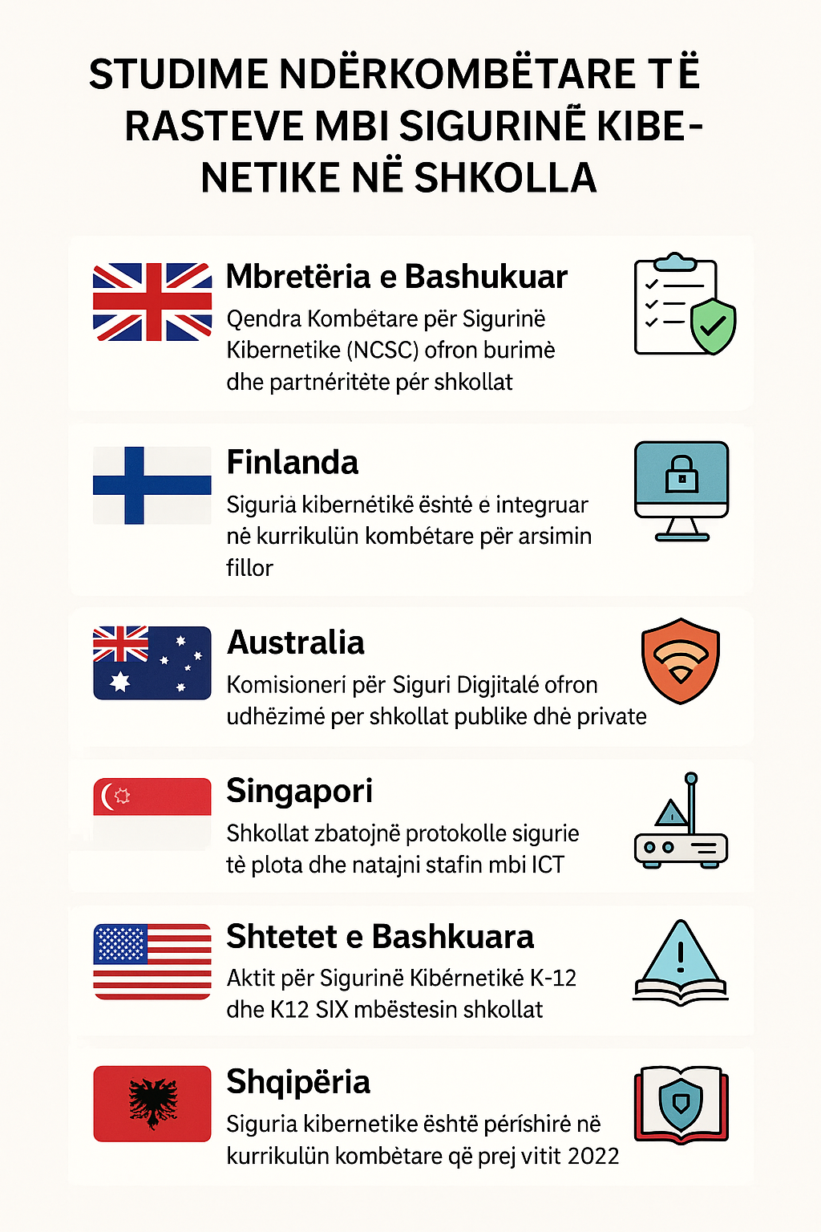

Singapore represents a technologically advanced education system that prioritizes cybersecurity infrastructure and awareness. The Ministry of Education requires schools to implement comprehensive security protocols, conduct vulnerability assessments, and educate staff through the ICT Competency Framework. Public campaigns such as “Cyber Wellness” promote healthy digital behavior through games, storytelling, and peer-led initiatives. Notably, Singapore’s strategy involves strong public-private partnerships, with support from companies like Singtel and GovTech (Ministry of Education Singapore, 2020).

In the United States, efforts vary significantly by state and district. However, national initiatives like the K-12 Cybersecurity Act and the work of K12 SIX provide guidance and threat intelligence to school IT teams. Cybersecurity is also increasingly recognized in federal education funding programs, enabling districts to invest in secure infrastructure, staff training, and cyber insurance (K12 Security Information Exchange, 2021).

In Albania, cybersecurity is gaining increasing importance within the educational system through a comprehensive approach. Since 2022, this topic has been integrated into the national pre-university curriculum, teaching students concepts such as online safety, personal data protection, and responsible use of technology — both through dedicated subjects and within existing core subjects.

During Safer Internet Month 2025, over 1,100 schools organized awareness sessions in collaboration with the Ministry of Education and Sports and with parent councils. At the same time, the National Authority for Cybersecurity (AKSK) launched training programs for teachers and school safety coordinators, focusing on topics such as digital bullying, sexual harassment, online gaming risks, and data protection.

Albania also cooperates with international organizations such as the ITU to improve standards for child online protection, while local universities offer master’s programs in the field of information security. Recently, work has begun on establishing a Cybersecurity Academy to further develop national capacities.

These case studies demonstrate that effective cybersecurity in schools requires more than just technical protection; it depends on consistent leadership, cultural alignment, and collaboration across the entire ecosystem. By learning from international best practices and adapting them to local contexts, schools around the world can strengthen their resilience and foster a safer digital learning environment for all students.

1. **Psychosocial Impact of Cyber Threats on Students**

Cyber threats in educational environments extend beyond technical disruptions—they can profoundly affect students’ psychological well-being, academic engagement, and social development. As digital platforms become integrated into students’ daily lives, they are increasingly exposed to harmful online behaviors such as cyberbullying, doxing, and exploitative content, which may lead to long-lasting emotional consequences.

Cyberbullying, in particular, has been consistently linked to heightened levels of anxiety, depression, and social isolation among adolescents. Victims may experience a decline in academic performance, avoidance of school-related activities, and even suicidal ideation in extreme cases. Unlike traditional bullying, online abuse can occur continuously, with victims unable to escape the threats due to the ubiquitous nature of smartphones and social media platforms (Kowalski et al., 2014).

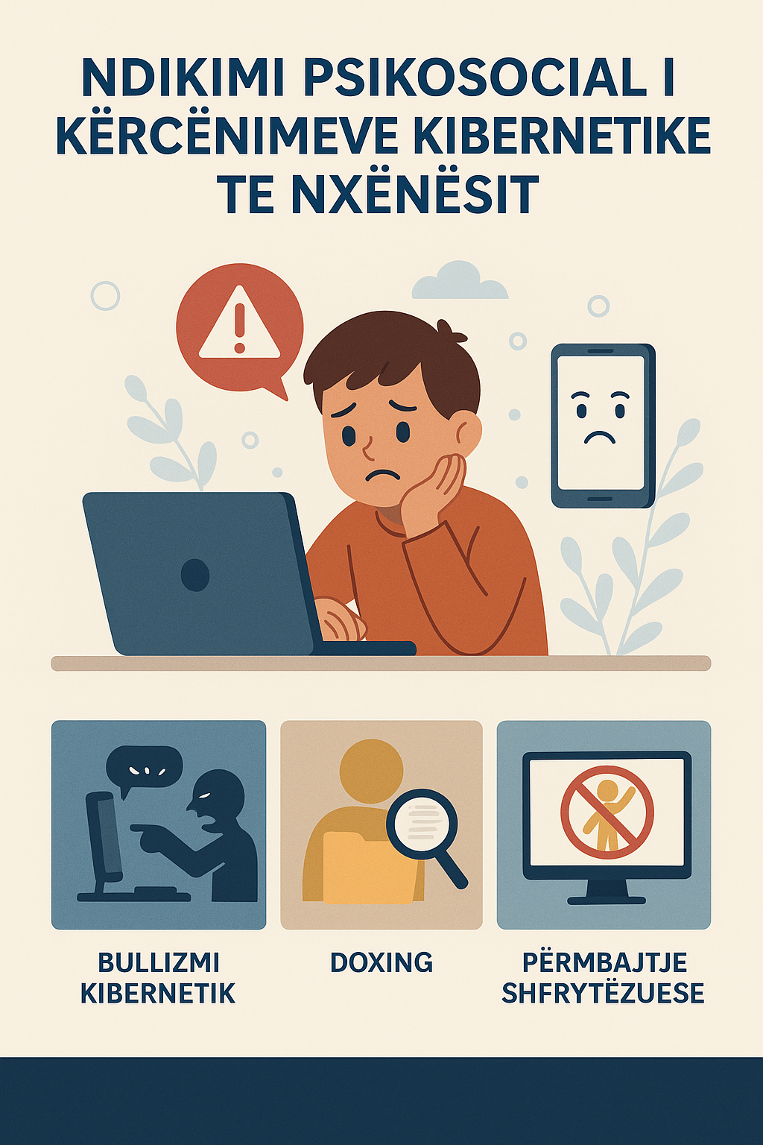

The psychological toll is further exacerbated by incidents of online impersonation, hacking of social media accounts, and the dissemination of private images without consent. Such attacks often undermine students’ sense of autonomy, trust in authority figures, and belief in their own digital competence. Moreover, students who engage in online aggression—either as perpetrators or bystanders—may also face negative developmental outcomes, including desensitization, normalization of harm, and impaired empathy (Patchin & Hinduja, 2018).

Exposure to data breaches or identity theft can also trigger emotional distress. When students discover that their personal or academic records have been accessed without permission, they may experience fear, confusion, and a loss of confidence in their institution’s ability to protect them. These feelings are particularly intense when incidents are not communicated transparently or when appropriate support mechanisms are lacking.

In addressing these psychosocial effects, schools must take a holistic approach. First, mental health services must be integrated into cybersecurity policies and incident response frameworks. School counselors should be trained to recognize signs of digital trauma and provide timely support. Collaboration between IT staff, educators, and mental health professionals is essential for developing response protocols that prioritize student well-being.

Second, the curriculum should include digital empathy education. Teaching students to understand how their online actions affect others can foster compassion, reduce harmful behavior, and create a safer online environment. Programs like SEL (Social and Emotional Learning) can be adapted to incorporate digital scenarios, helping students build both interpersonal and digital resilience (Livingstone & Stoilova, 2021).

Finally, student voice should be central in designing prevention and response strategies. By engaging youth in peer mentoring, school policy development, and cyber safety advocacy, schools empower students to become proactive agents of change in their digital communities.

Understanding the psychosocial dimensions of cyber threats is crucial for designing effective, compassionate school responses. Schools that integrate digital safety with emotional health initiatives are better equipped to foster not only secure but also supportive learning environments.

**Conclusion**

Cyber hygiene in educational settings is no longer an optional practice—it is a critical component of safeguarding the digital and emotional well-being of students, educators, and institutional systems. As the digital landscape continues to evolve, schools face not only a rising tide of technical threats, but also increasing responsibility to foster environments that are both secure and supportive.

This guide has explored a comprehensive array of cyber hygiene dimensions, from foundational security practices and curriculum integration, to mental health implications and global policy examples. What becomes clear across these areas is that cybersecurity in education requires a whole-system approach. Technical defenses such as password management, software updates, and threat monitoring must be paired with proactive educational efforts, inclusive policymaking, and strong community partnerships.

Moreover, students must be positioned not as passive recipients of protection, but as active participants in the culture of cybersecurity. Through awareness, empowerment, and digital empathy, young people can contribute to the creation of safe online spaces that support learning, collaboration, and creativity.

As schools look to the future, the integration of cybersecurity into every aspect of educational life—from infrastructure to instruction—will be essential. By building strong foundations today, schools can ensure that students are equipped not only to navigate but to shape the digital world safely, ethically, and confidently.

Cyber hygiene is a shared responsibility, and its success depends on the coordinated efforts of educators, families, policymakers, and students themselves. With intentional action and sustained commitment, schools can transform cybersecurity from a technical challenge into a platform for holistic educational excellence.

**Bibliography**

Be Internet Awesome. (2023). *Be Internet Awesome curriculum*. Google. https://beinternetawesome.withgoogle.com/en_us

Center for Internet Security. (2022). *CIS controls v8*. https://www.cisecurity.org/controls

Cecchinato, M. E., Cox, A. L., & Bird, J. (2021). *Digital wellbeing and learning: A socio-technical perspective*. Computers & Education, 167, 104175.

CISA. (2022). *Protecting our future: Partnering to safeguard K–12 organizations from cybersecurity threats*. U.S. Cybersecurity and Infrastructure Security Agency.

Common Sense Media. (2022). *Digital citizenship curriculum*. https://www.commonsense.org/education

ConnectSafely. (2022). *Parent guides and resources*. https://www.connectsafely.org

CoSN. (2021). *Driving K-12 innovation: 2021 hurdles + accelerators*. Consortium for School Networking.

Cyber.org. (2023). *Cybersecurity education resources*. https://www.cyber.org

Data Quality Campaign. (2022). *The state of student data privacy*. https://dataqualitycampaign.org

eSafety Commissioner. (2022). *Online safety education for schools*. Australian Government. https://www.esafety.gov.au

European Commission. (2021). *Ethics guidelines for trustworthy AI*. https://digital-strategy.ec.europa.eu

European Schoolnet. (2021). *Digital education in Finland*. https://www.eun.org

Family Online Safety Institute. (2022). *Parenting in the digital age report*. https://www.fosi.org

Internet Matters. (2023). *Supporting families online*. https://www.internetmatters.org

K12 Security Information Exchange (K12 SIX). (2021). *The state of K-12 cybersecurity: Year in review*. https://www.k12six.org

Kowalski, R. M., Giumetti, G. W., Schroeder, A. N., & Lattanner, M. R. (2014). Bullying in the digital age: A critical review and meta-analysis of cyberbullying research among youth. *Psychological Bulletin*, 140(4), 1073–1137.

Livingstone, S., & Byrne, J. (2018). *Children’s rights in the digital age: A download from children around the world*. LSE Media Policy Brief Series.

Livingstone, S., & Stoilova, M. (2021). *The outcomes of digital wellbeing and SEL in youth online safety education*. EU Kids Online.

Microsoft. (2021). *Cyber signals: Defending against identity compromise*. https://www.microsoft.com/security/blog

Ministry of Education Singapore. (2020). *Cyber wellness education in Singapore schools*. https://www.moe.gov.sg

National Cyber Security Centre (UK). (2022). *Cyber security for schools toolkit*. https://www.ncsc.gov.uk

NIST. (2021). *Computer security incident handling guide (SP 800-61 Rev. 2)*. National Institute of Standards and Technology.

OECD. (2022). *The ethics of data collection and AI in education*. https://www.oecd.org

Patchin, J. W., & Hinduja, S. (2018). Sexting as an emerging concern for adolescent health: A review of the literature. *Pediatrics*, 141(Supplement 2), S189–S193.

Ponemon Institute. (2020). *The cost of a data breach report*. IBM Security.

Privacy International. (2020). *EdTech and student data privacy*. https://privacyinternational.org